**Creation of CI (Jobs) in Jenkins**

Type Of Jenkins Jobs: -

1. Freestyle Project
2. Maven Project
3. Pipeline
4. Multibranch Pipeline

Creation of Jobs: -

1. Freestyle Project Job Creation Steps. With build trigger # Build Periodically

# Select job name an entered Job name with Freestyle Project

# Add build step as execute shell and save the job

# Newly created job will be available on dashboard

# Click on newly created job and you will able to see the job status on job dashboard

# Click on build to execute or run job first time after first execution job will run automatically

# If you want to check job, out put the then click on build and check the job logs over the consol logs

# if you want stop the job then un-checked the build trigger and save the job, Job will stop running automatically.

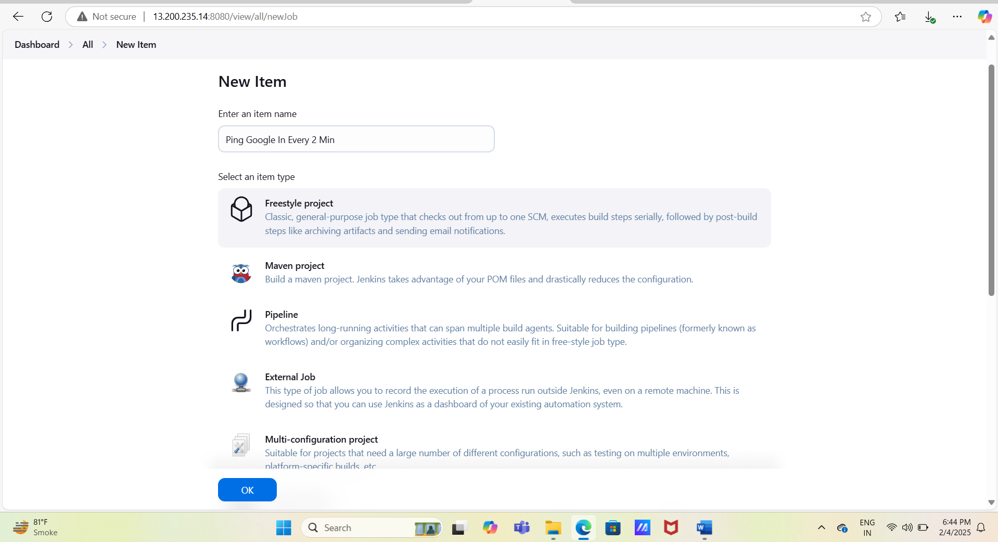

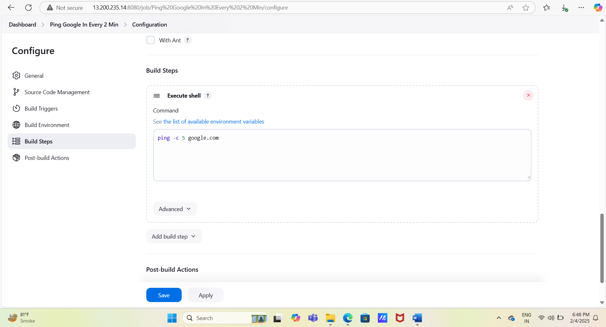

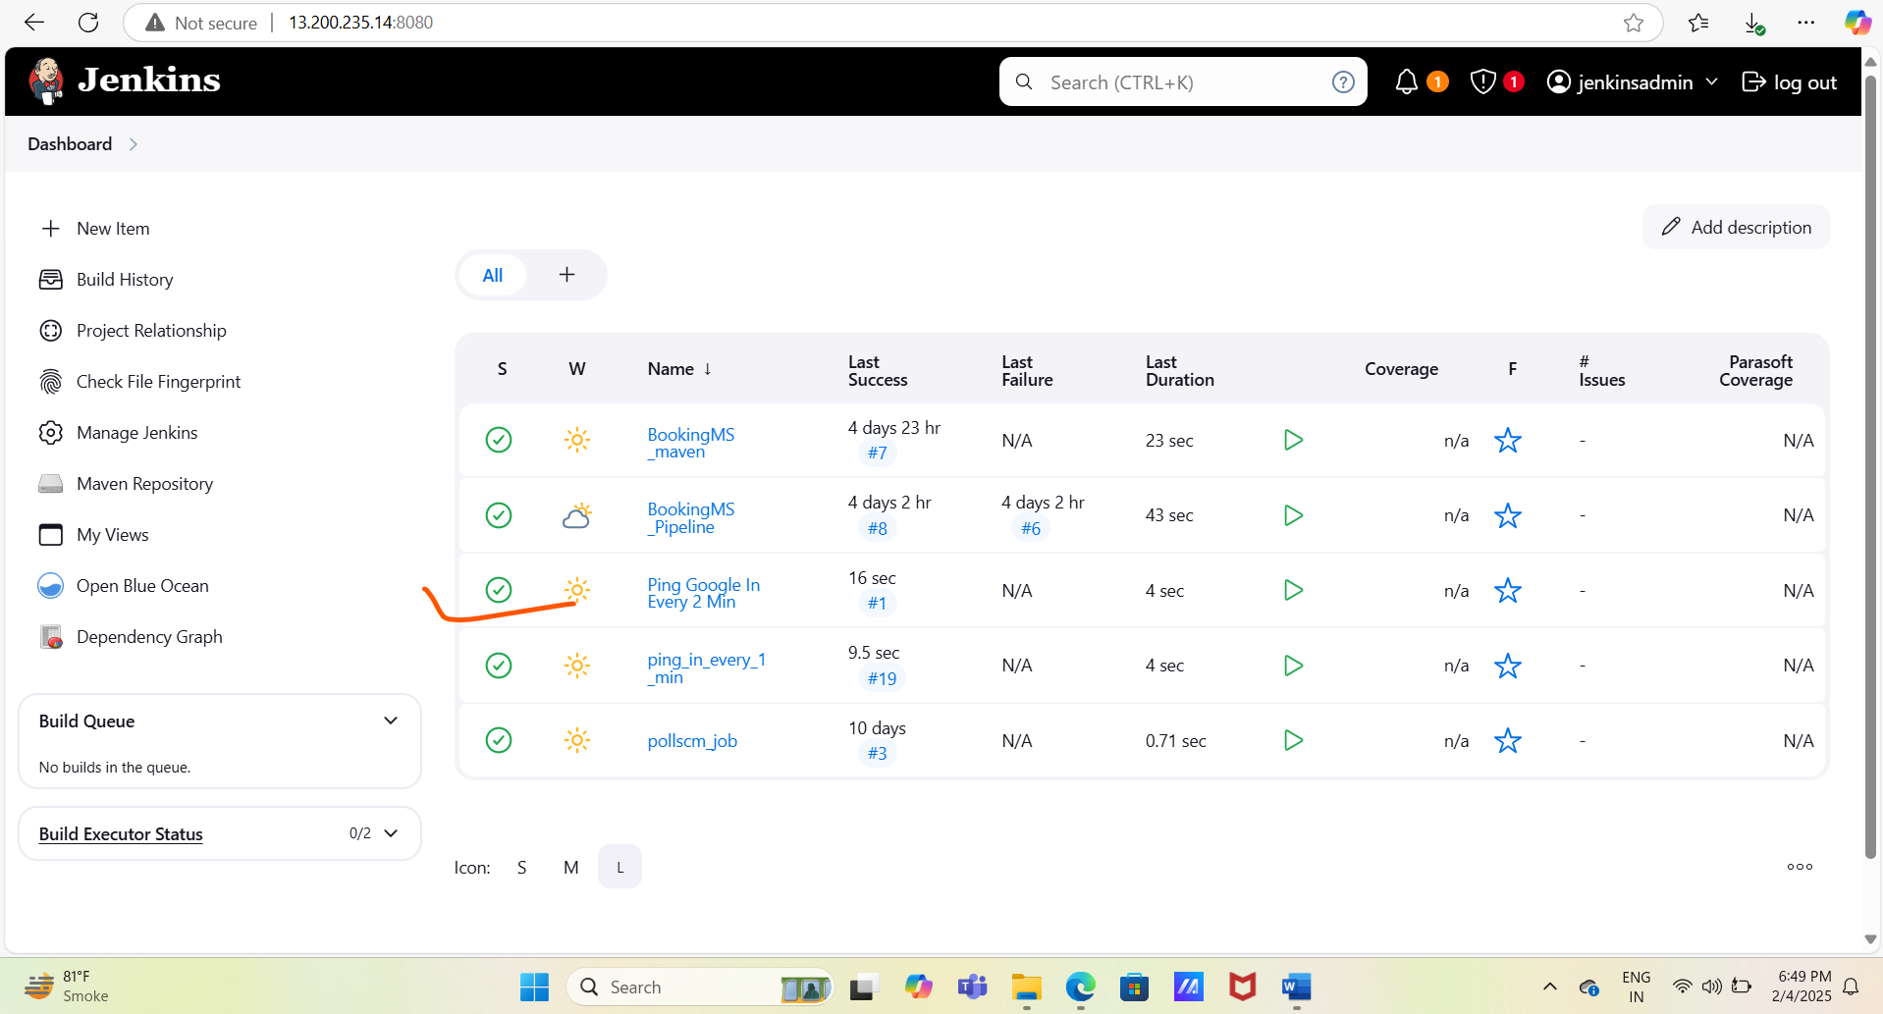

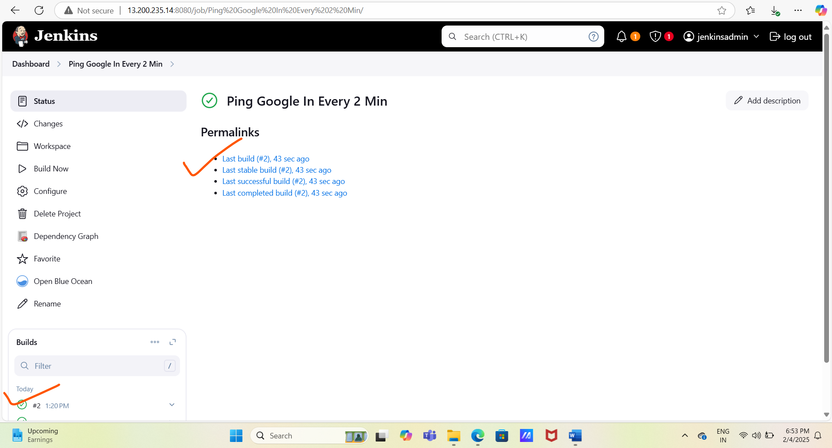

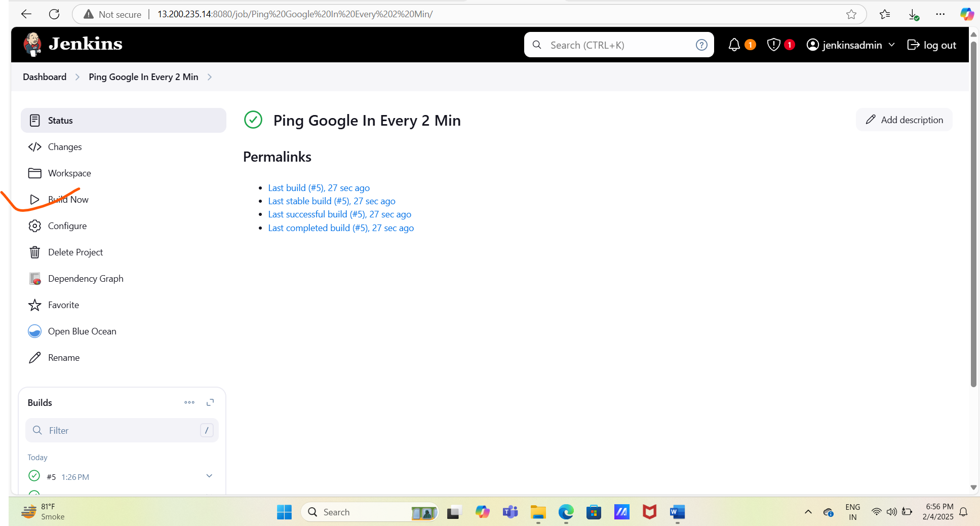

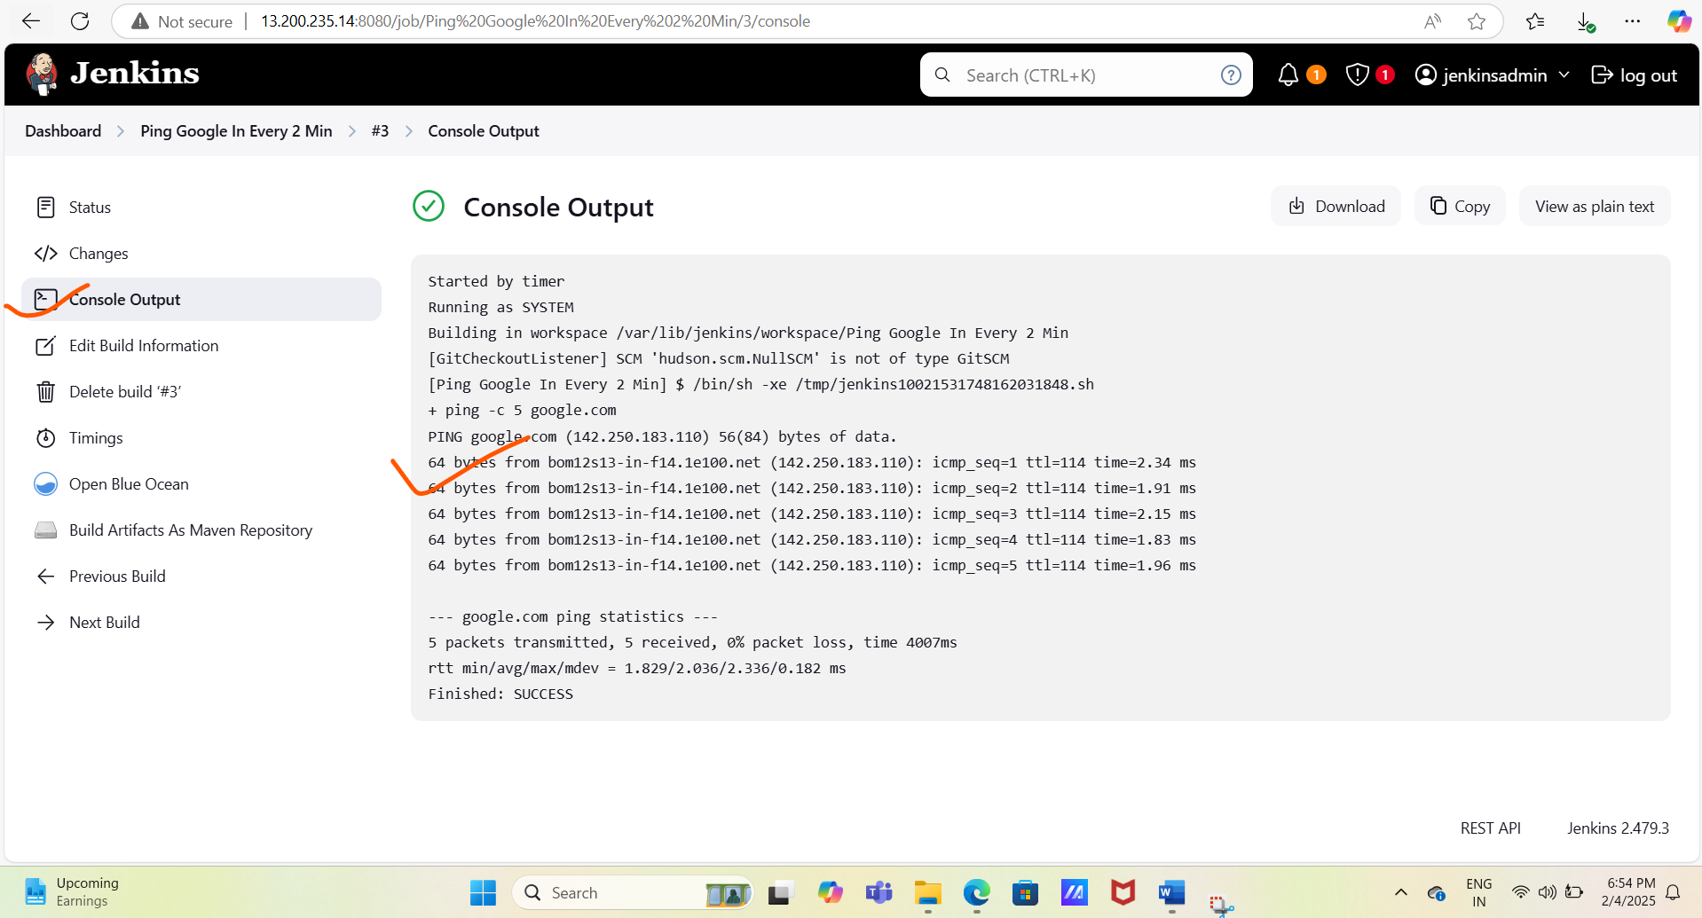

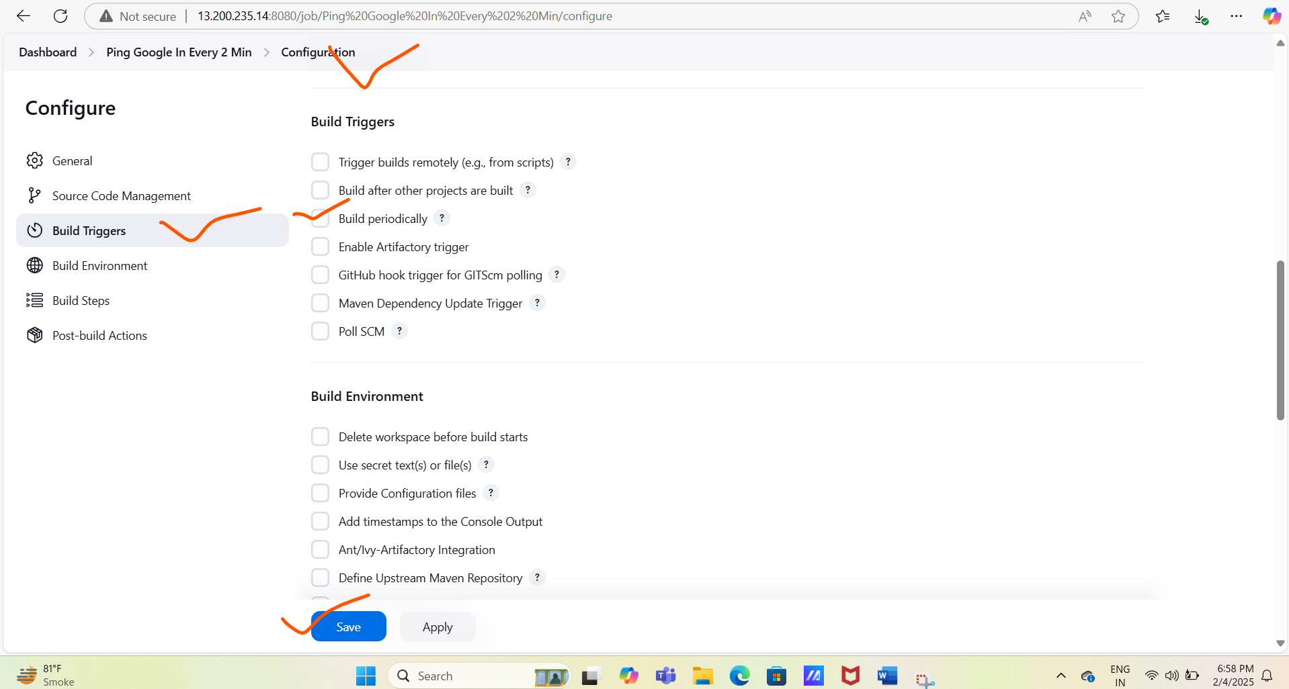

2.Freestyle Project Job Creation Steps. With build trigger # Poll SCM

#Click on new item and create new job with build trigger name Poll SCM and job type Freestyle Project.

# In this job we will use GitHub the repository to execute or run the job.

# Open the newly created job and click on configure and configure the newly created job.

#Copy the GitHub repository URL and add the URL in the Source Code Management (Git)

And select the branch as */master for newly added GitHub repository

# Select the Build trigger and add the crontab for every 1 min So job will check the latest GitHub repo for every 1 min (latest commit), And save the job

# Edit or update the GitHub repo and after this job will run automatically at every 1 min the pull the latest commit in GitHub repo.

# Now you can check the Job success or failed status on dashboard as well as in console logs using commit id from the GitHub.

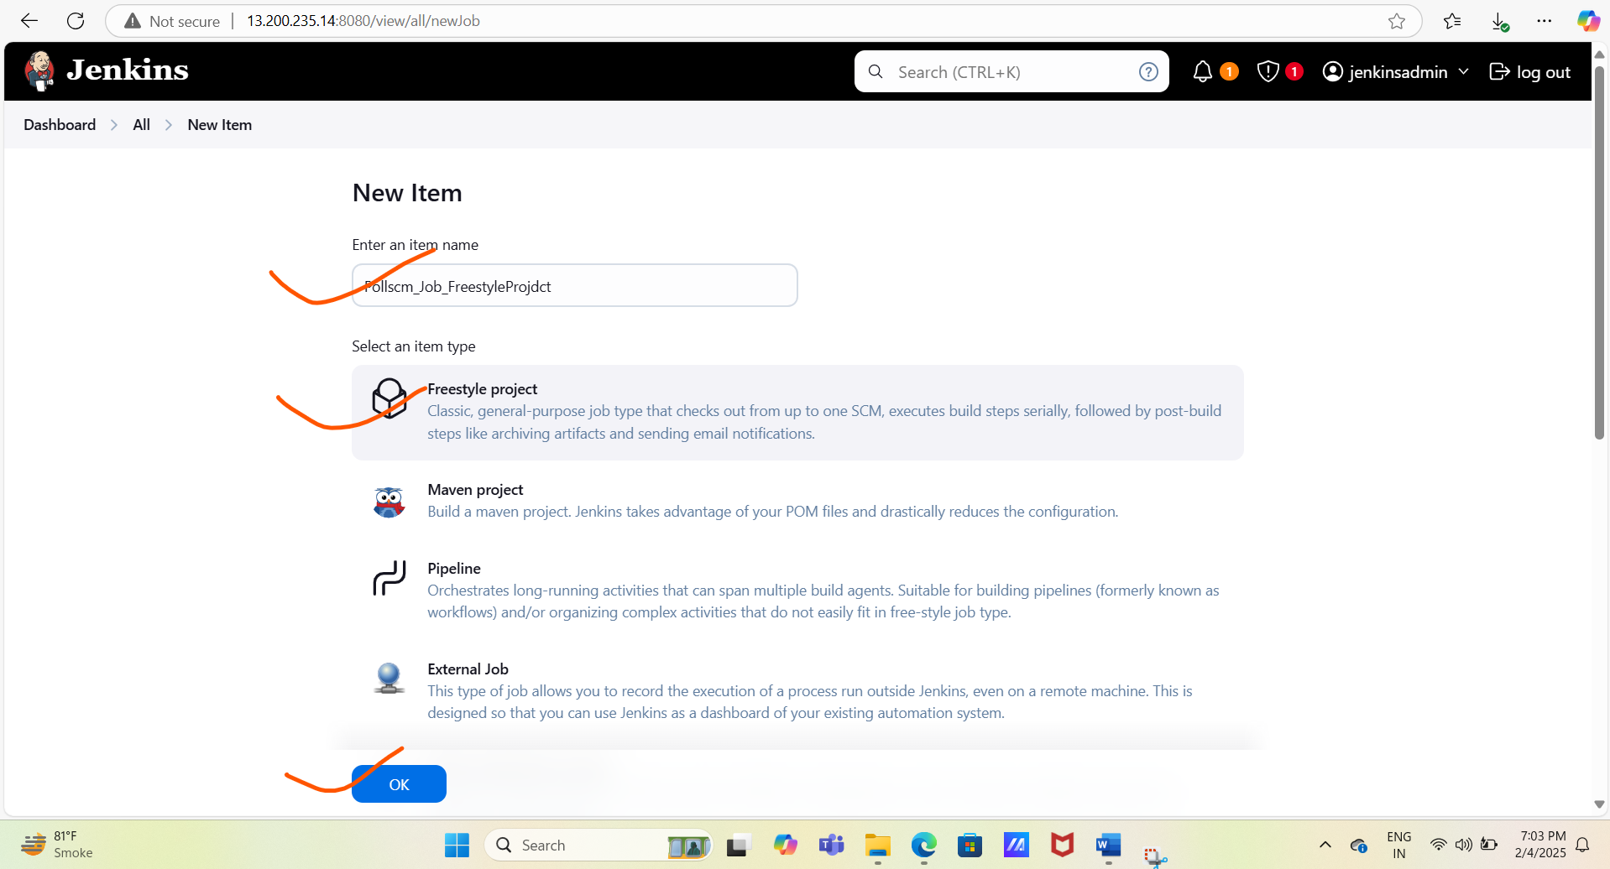

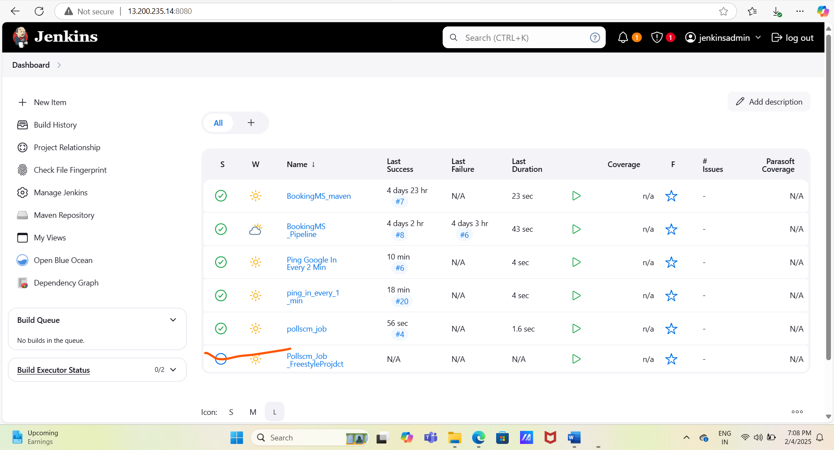

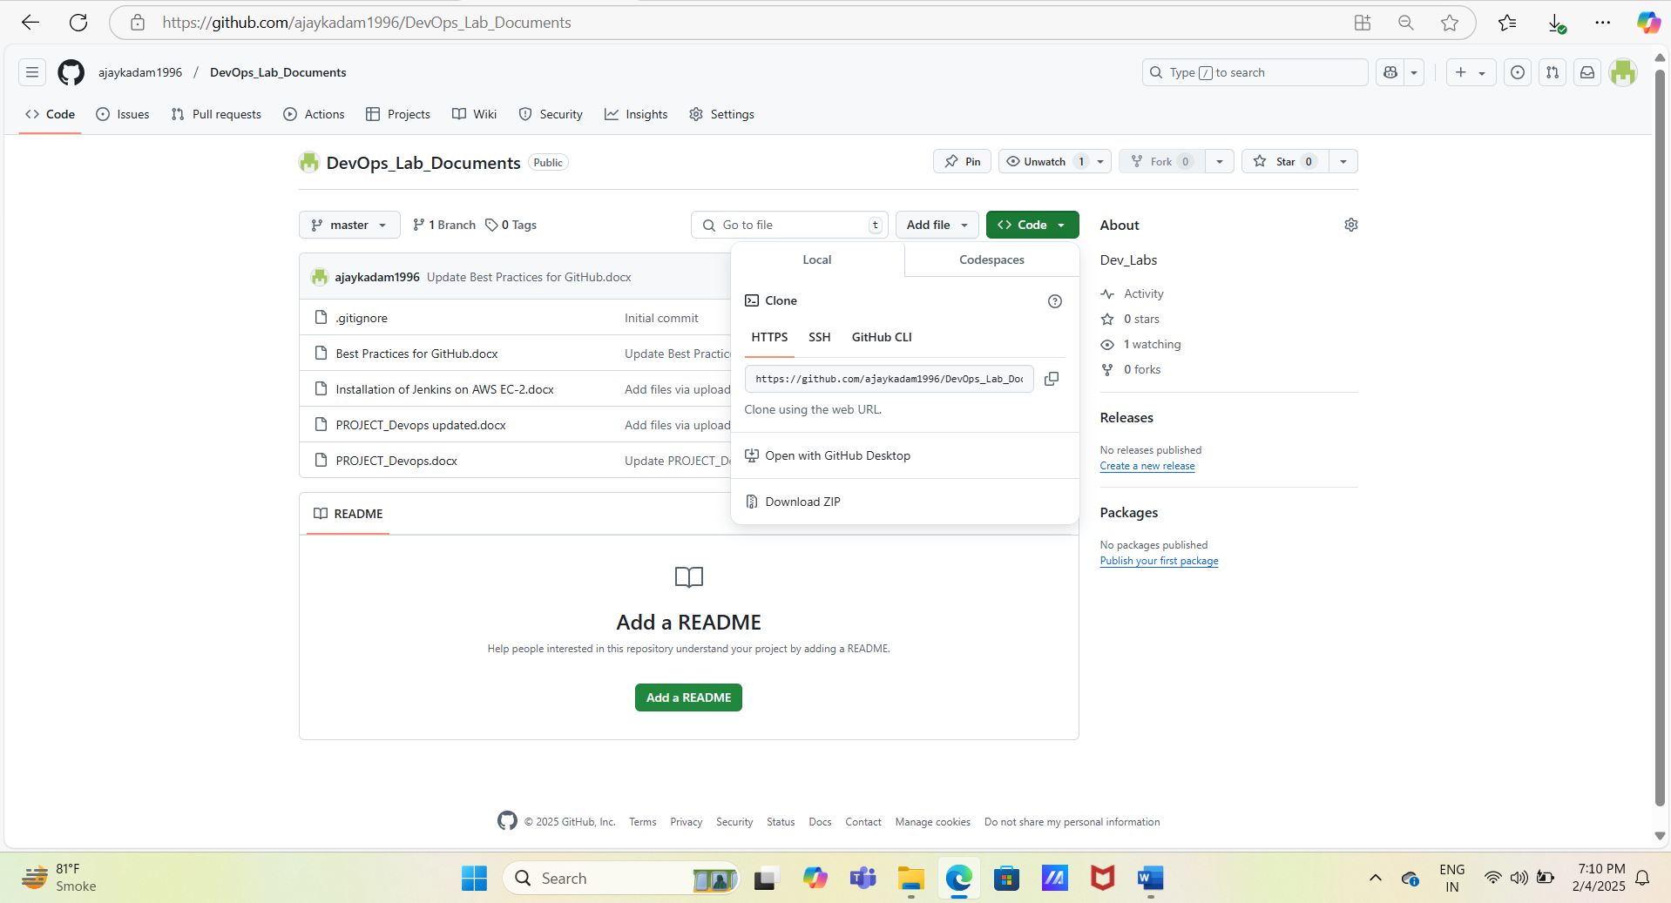

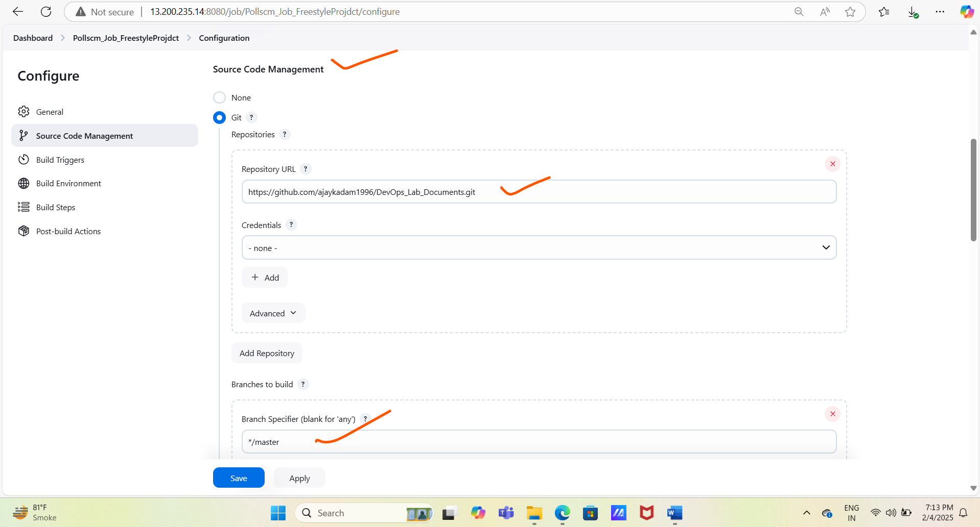

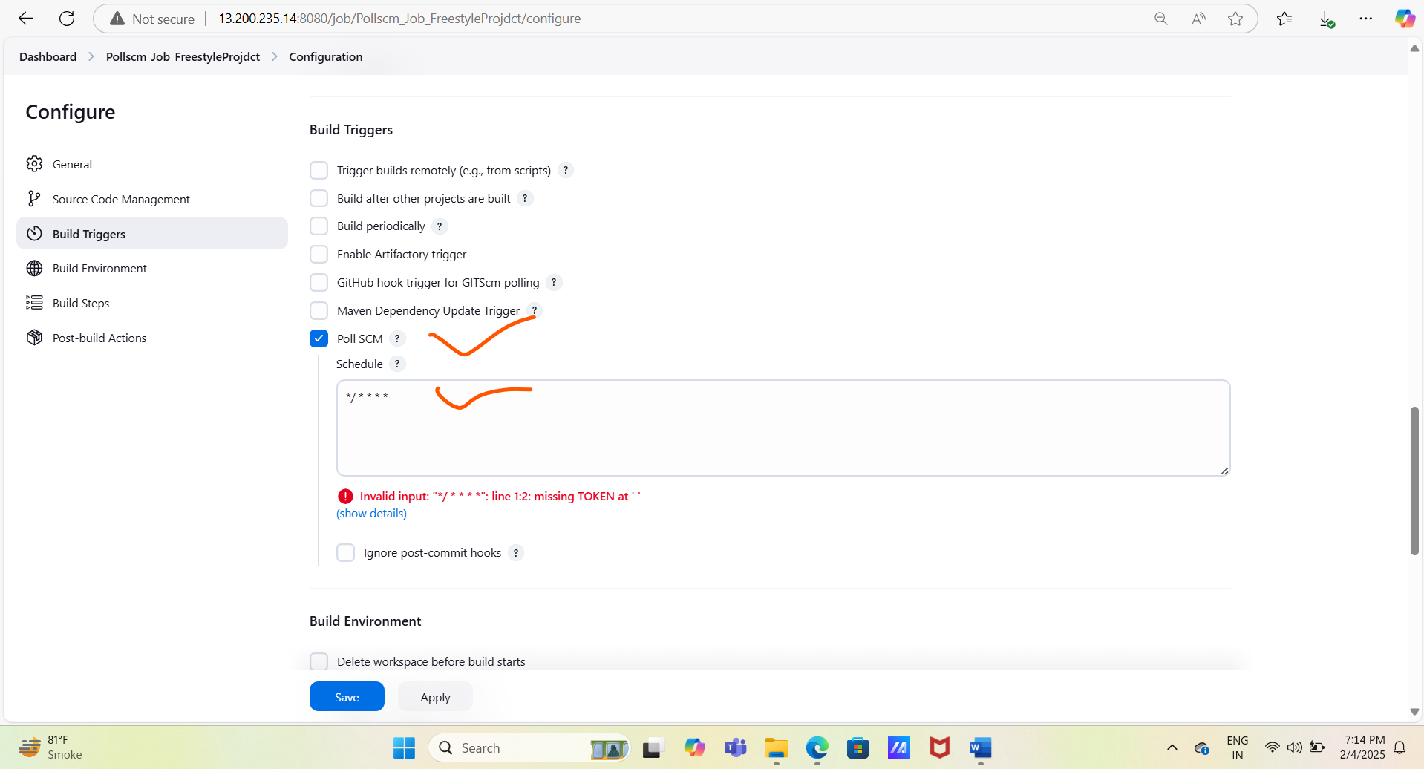

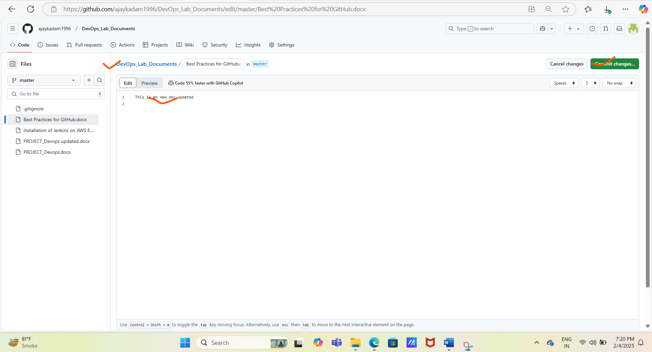

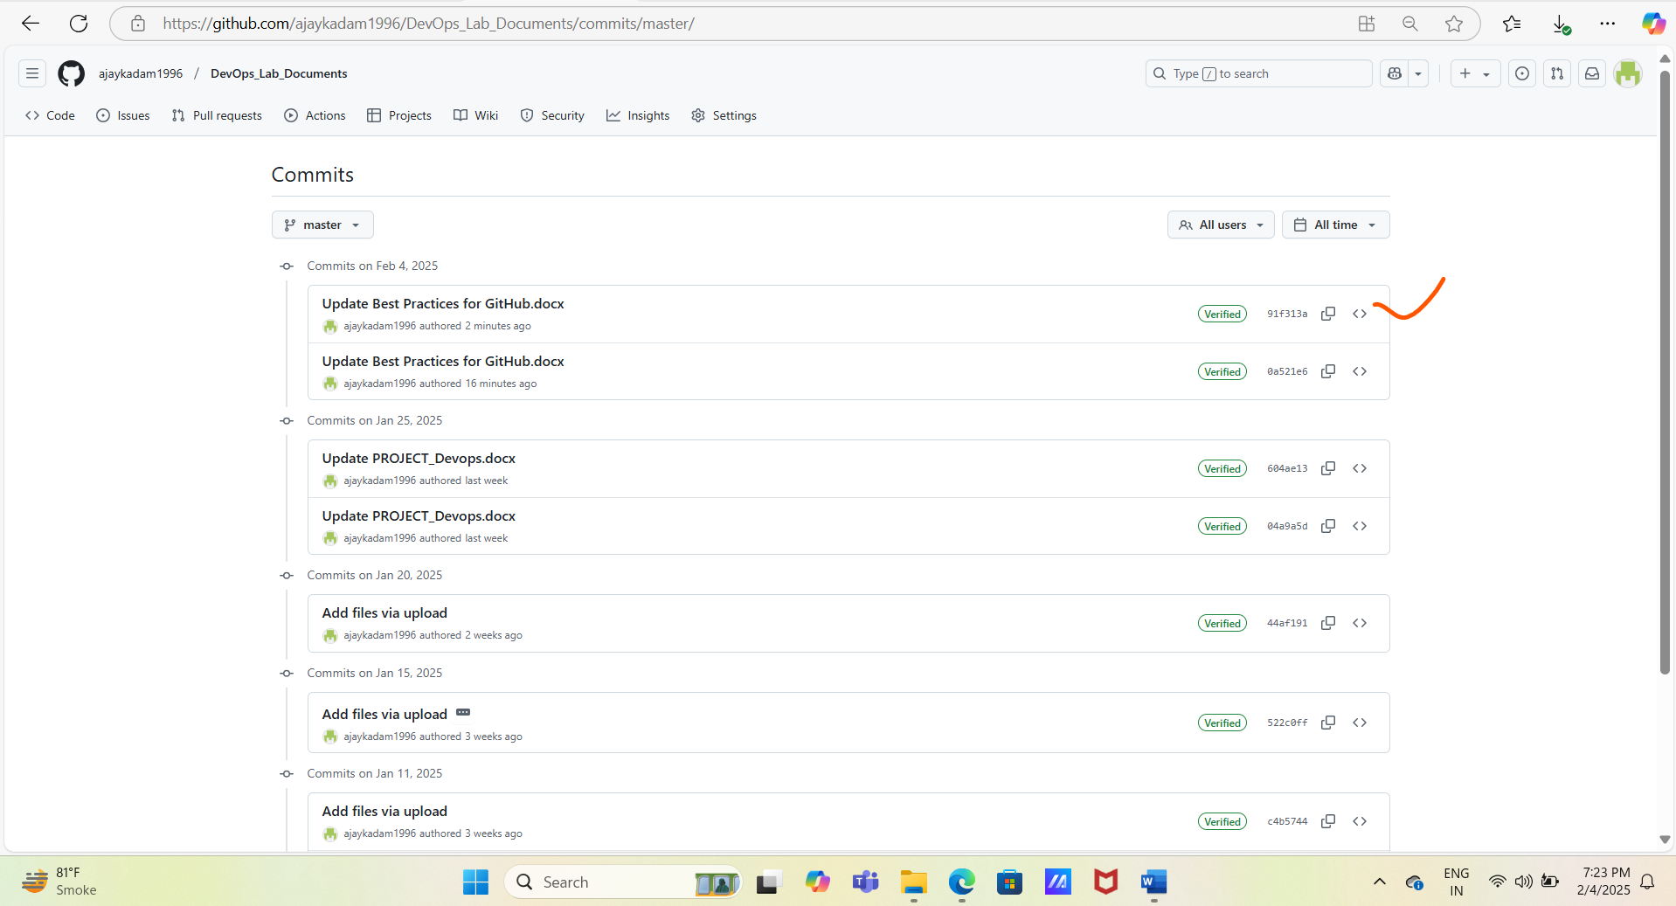

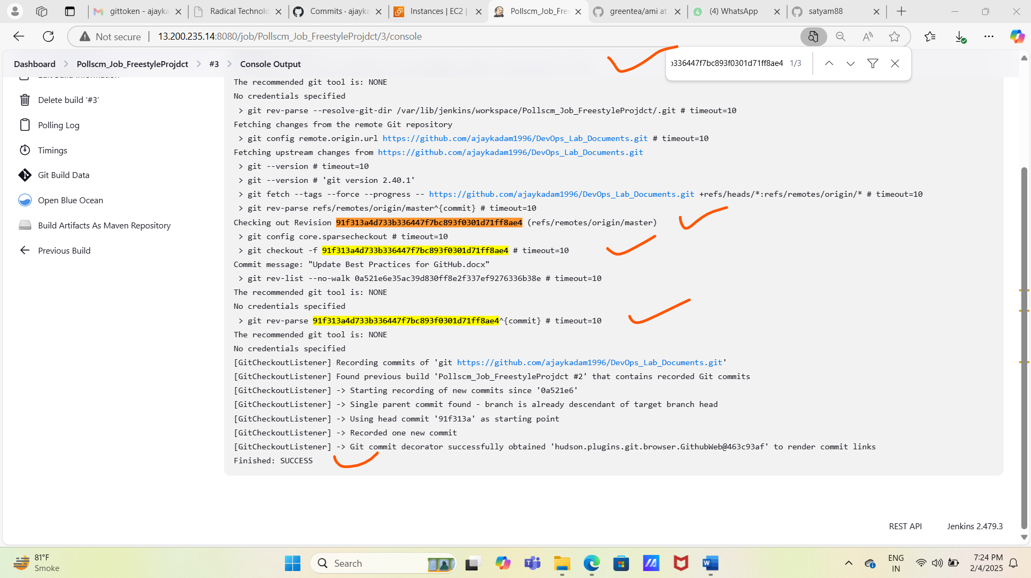

3.Maven Job Creation Steps. With build trigger # GitHub hook trigger for GITScm polling

# Create new Jenkins job Ex: - BookingMS_mavenwith build trigger GitHub hook trigger for GITScm polling

#Add GitHub repository and branch details in the source code management.

# As we are using maven project job type to create pipeline hence mention the # clean package

Maven command in the build option and save the job

#Login IntelliJ Idea and make same changes in the existing code or add new java class and push same code in the /dev branch ex:- we made changes in vacation class in destination field.

# Once commit/push happened in then login GitHub and check dashboard latest pull in dev job will be highlighted on GitHub dashboard. Then check Jenkins dashboard maven job will run automatically.

#you can check the job status using commit id from GitHub, copy commit id and search the same in the maven job console logs.

#Use below commands to make changes and push changes in the dev branch.

--git status

--git branch

--git checkout dev

--git pull origin dev

--mvn clean compile

--mvn clean package

--git add –all

--git commit -m “change in vacation class Kashmir to manali”

--git push origin dev ( note do not push any changes directly in dev)

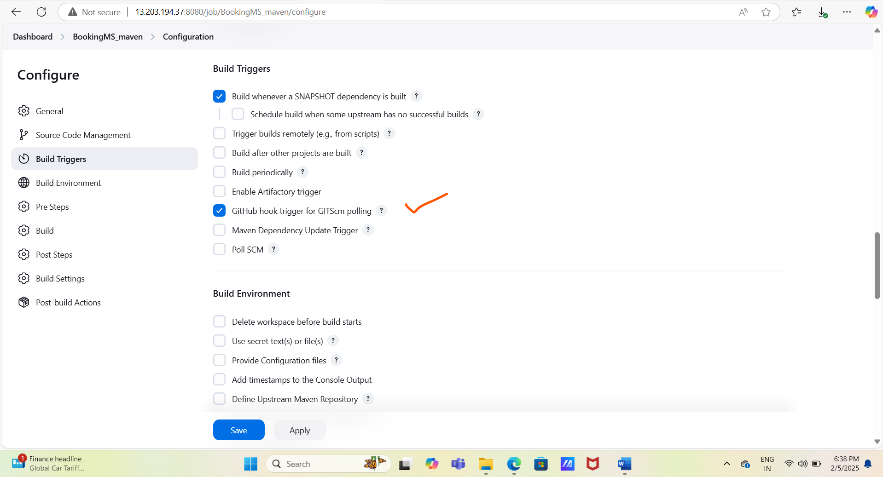

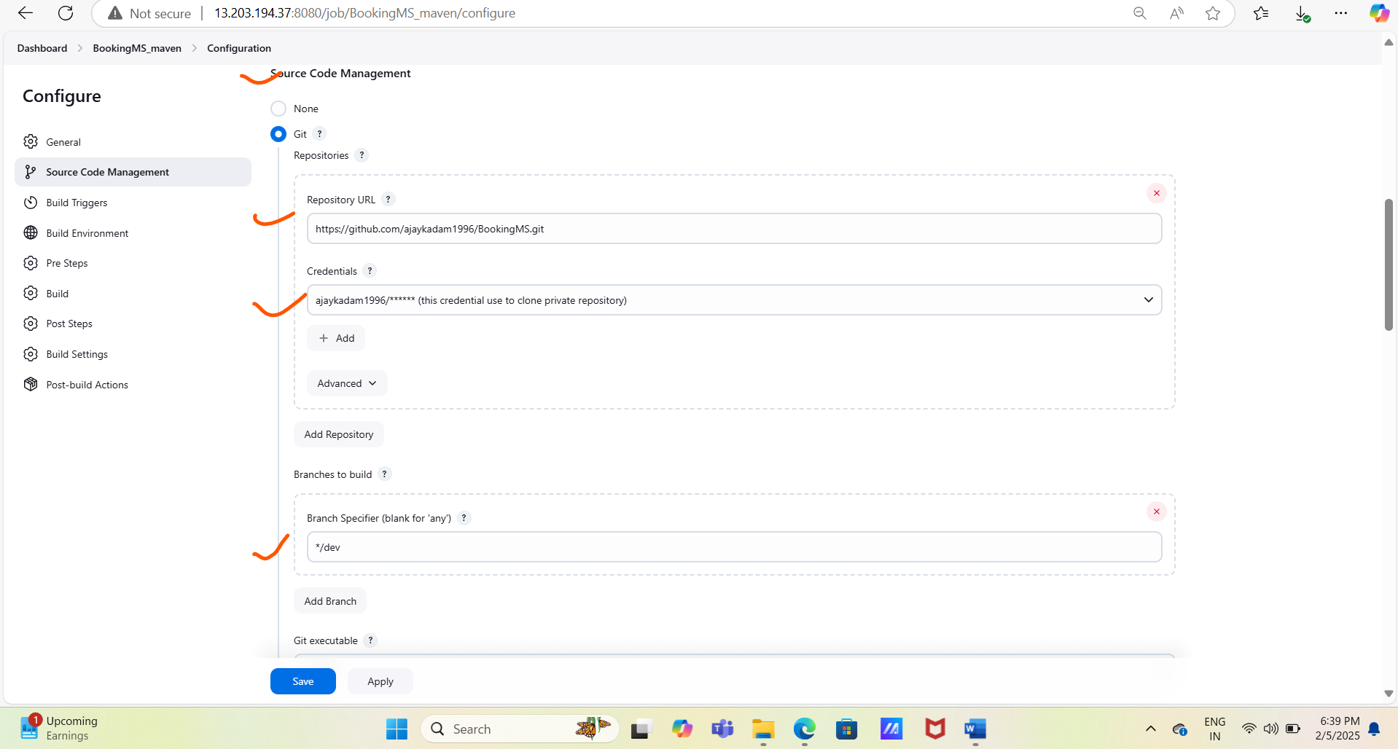

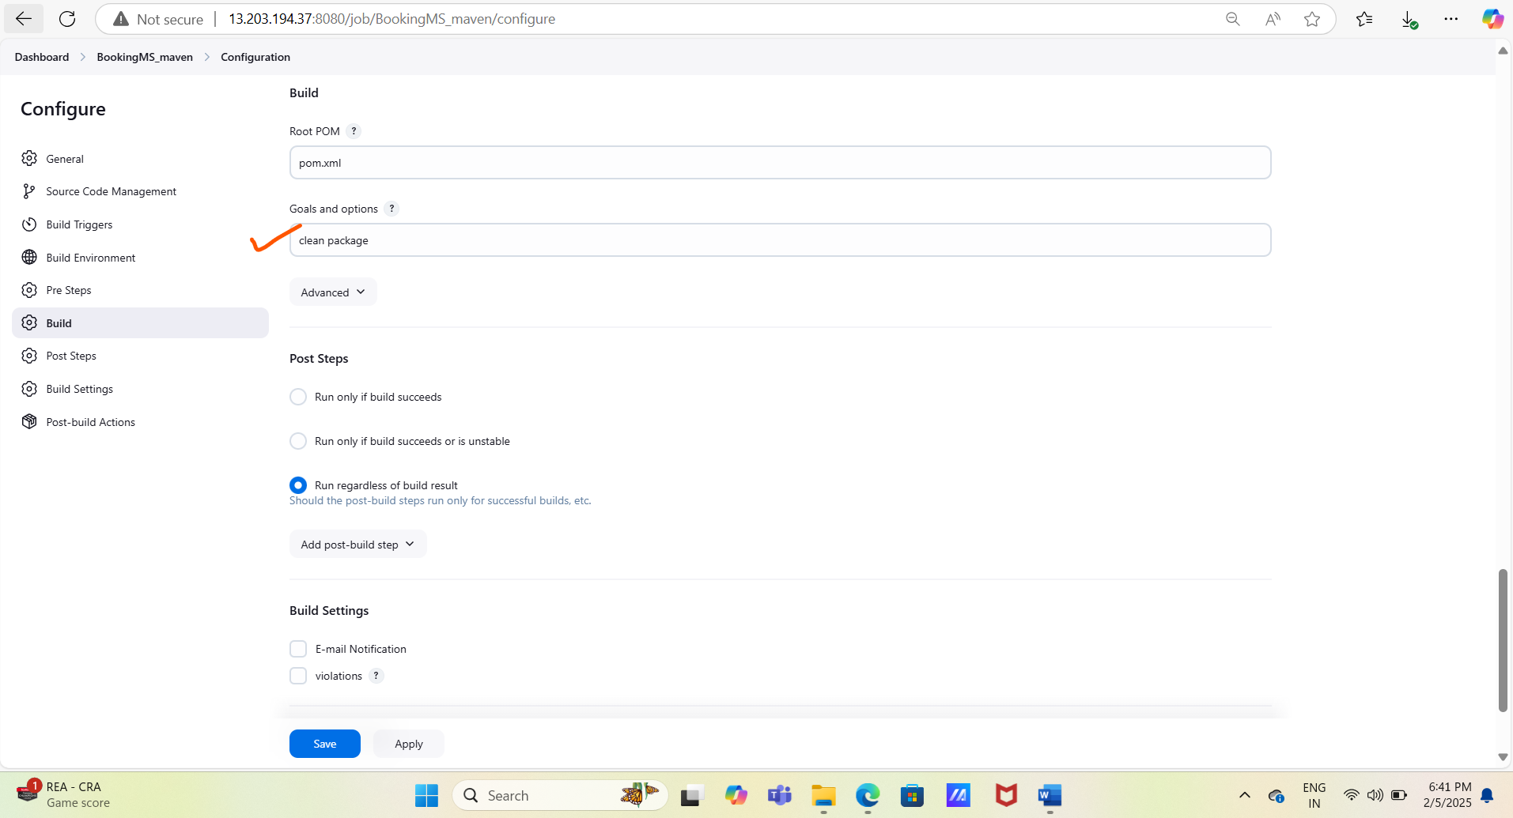

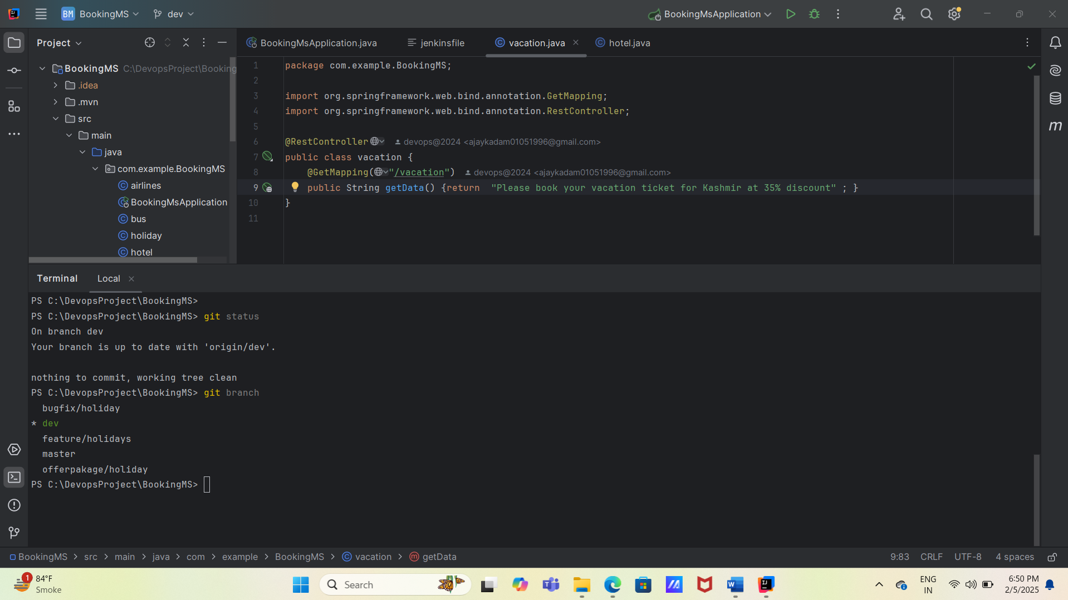

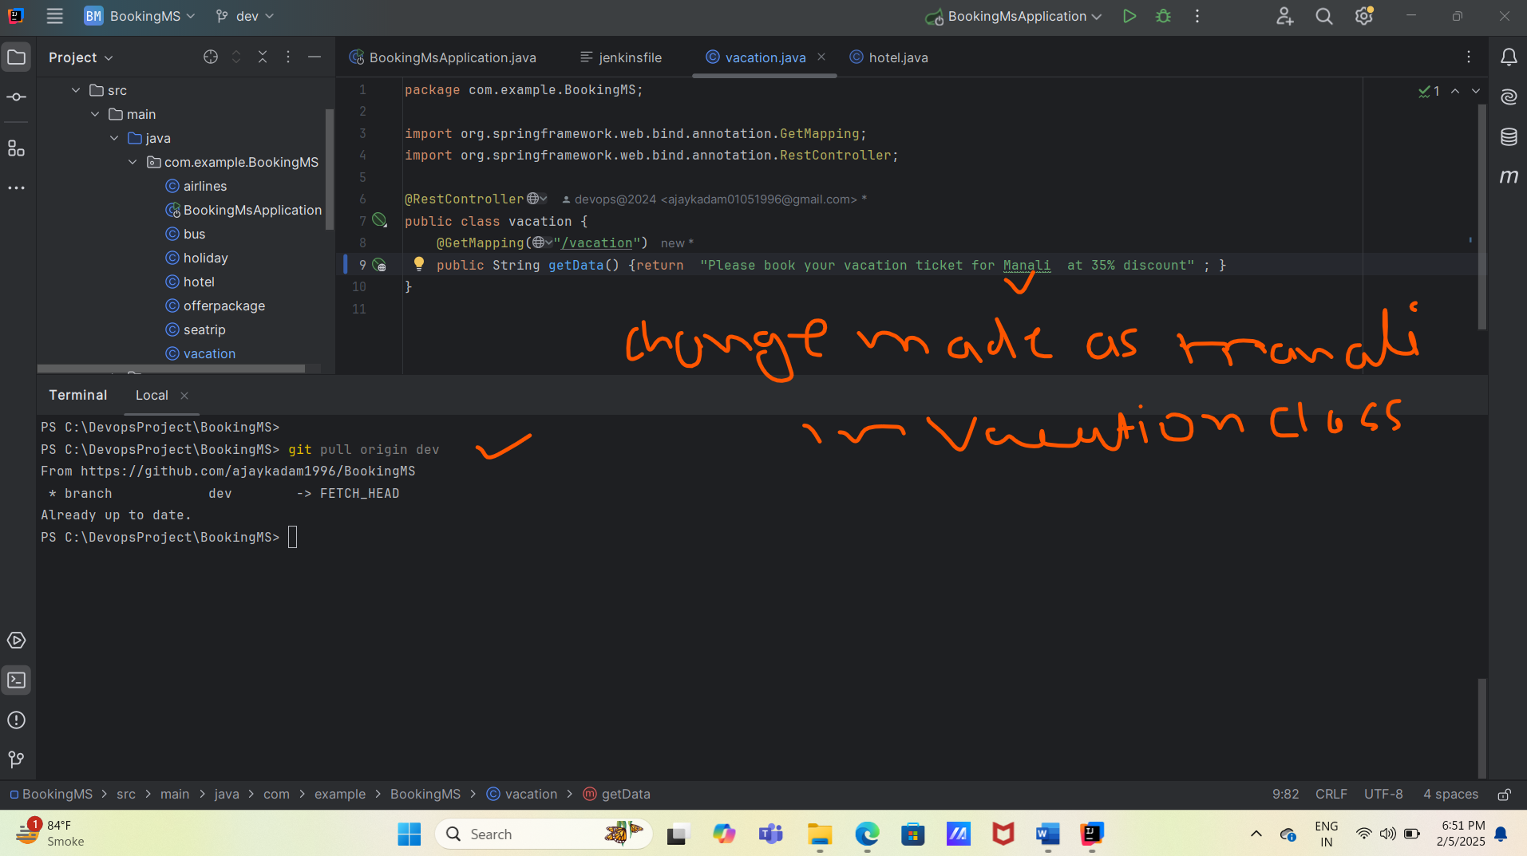

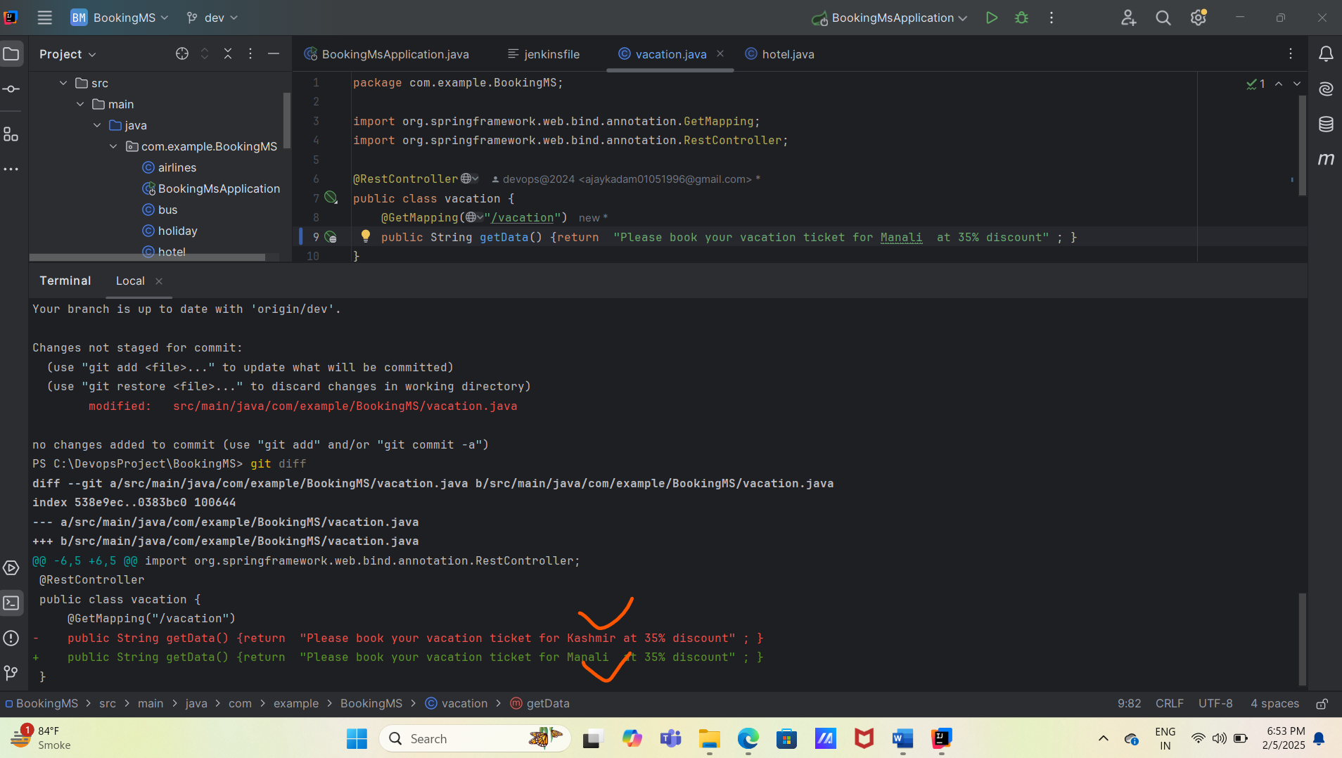

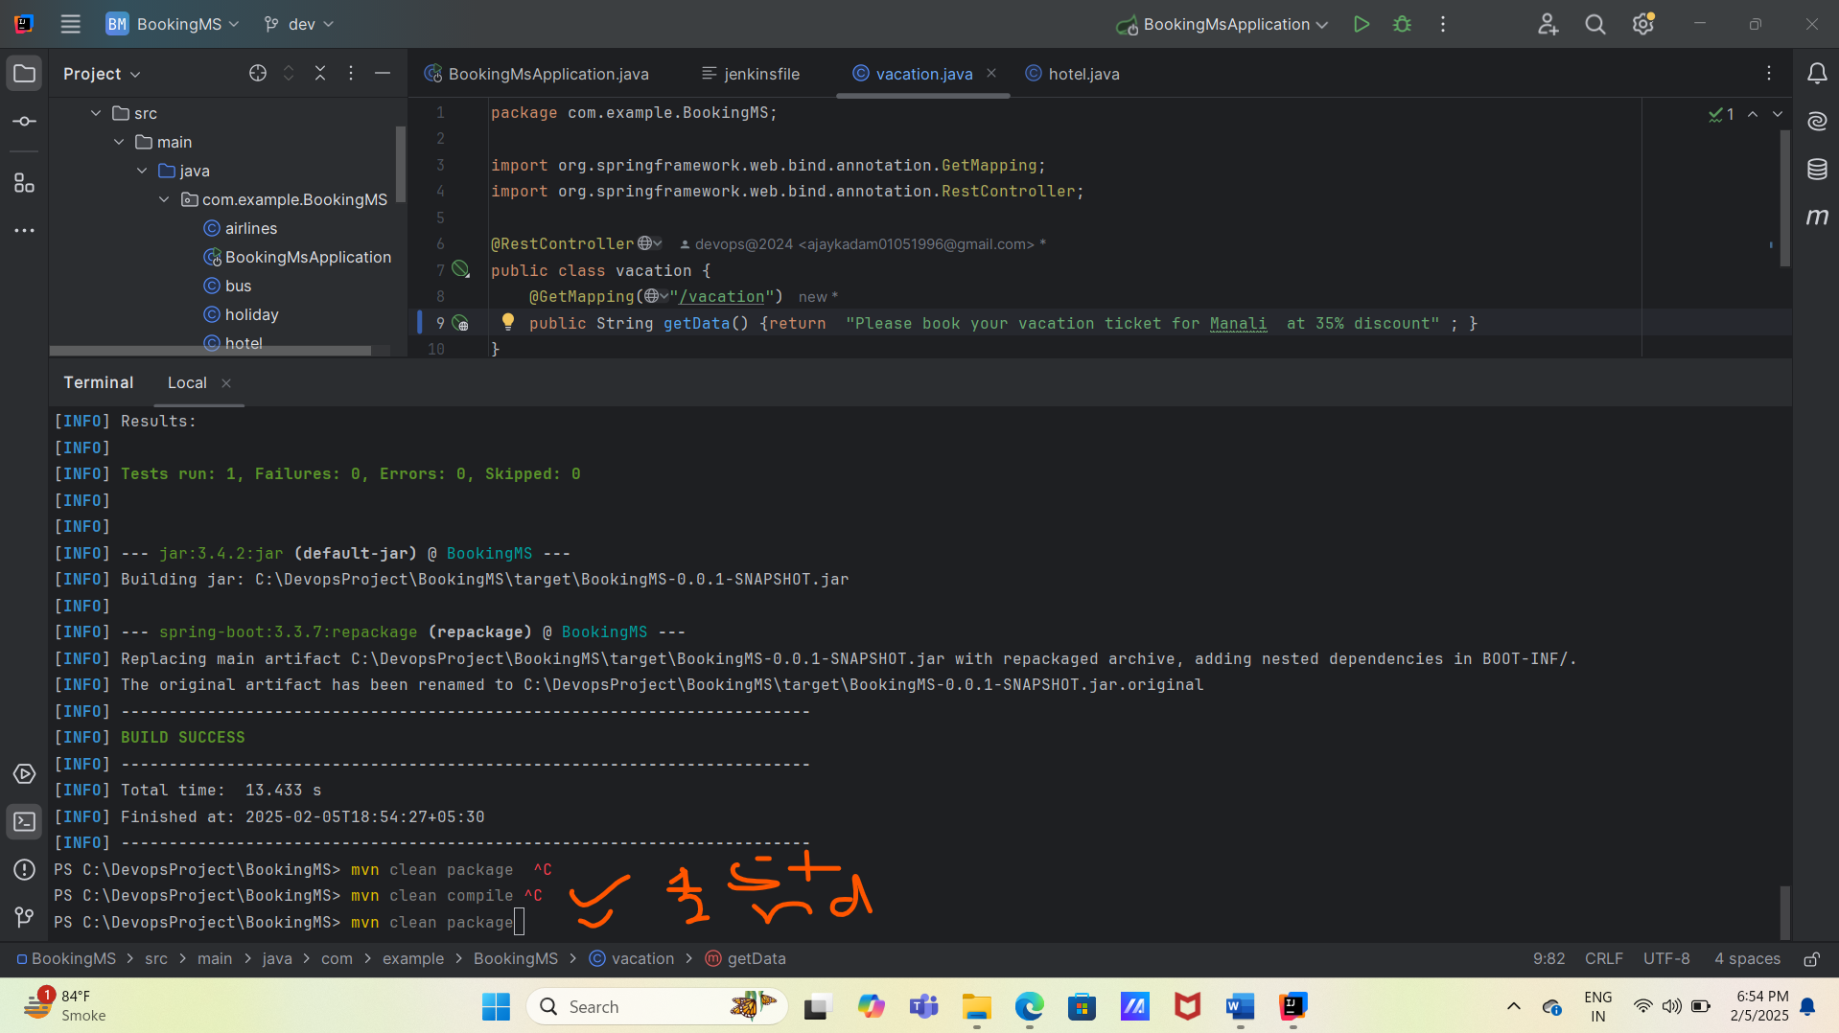

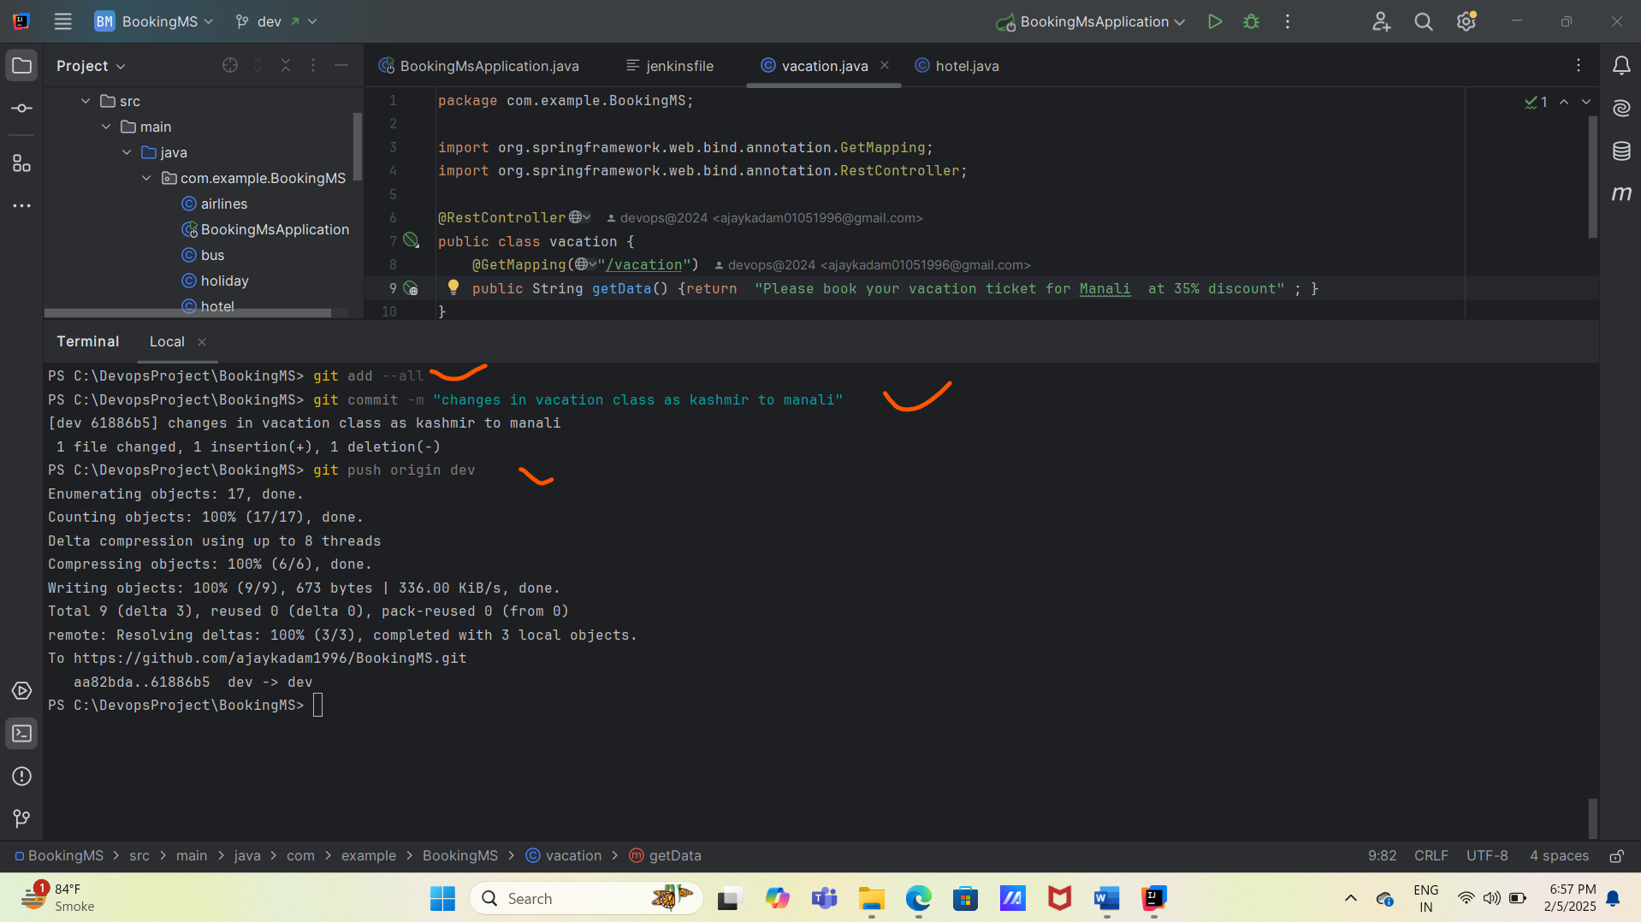

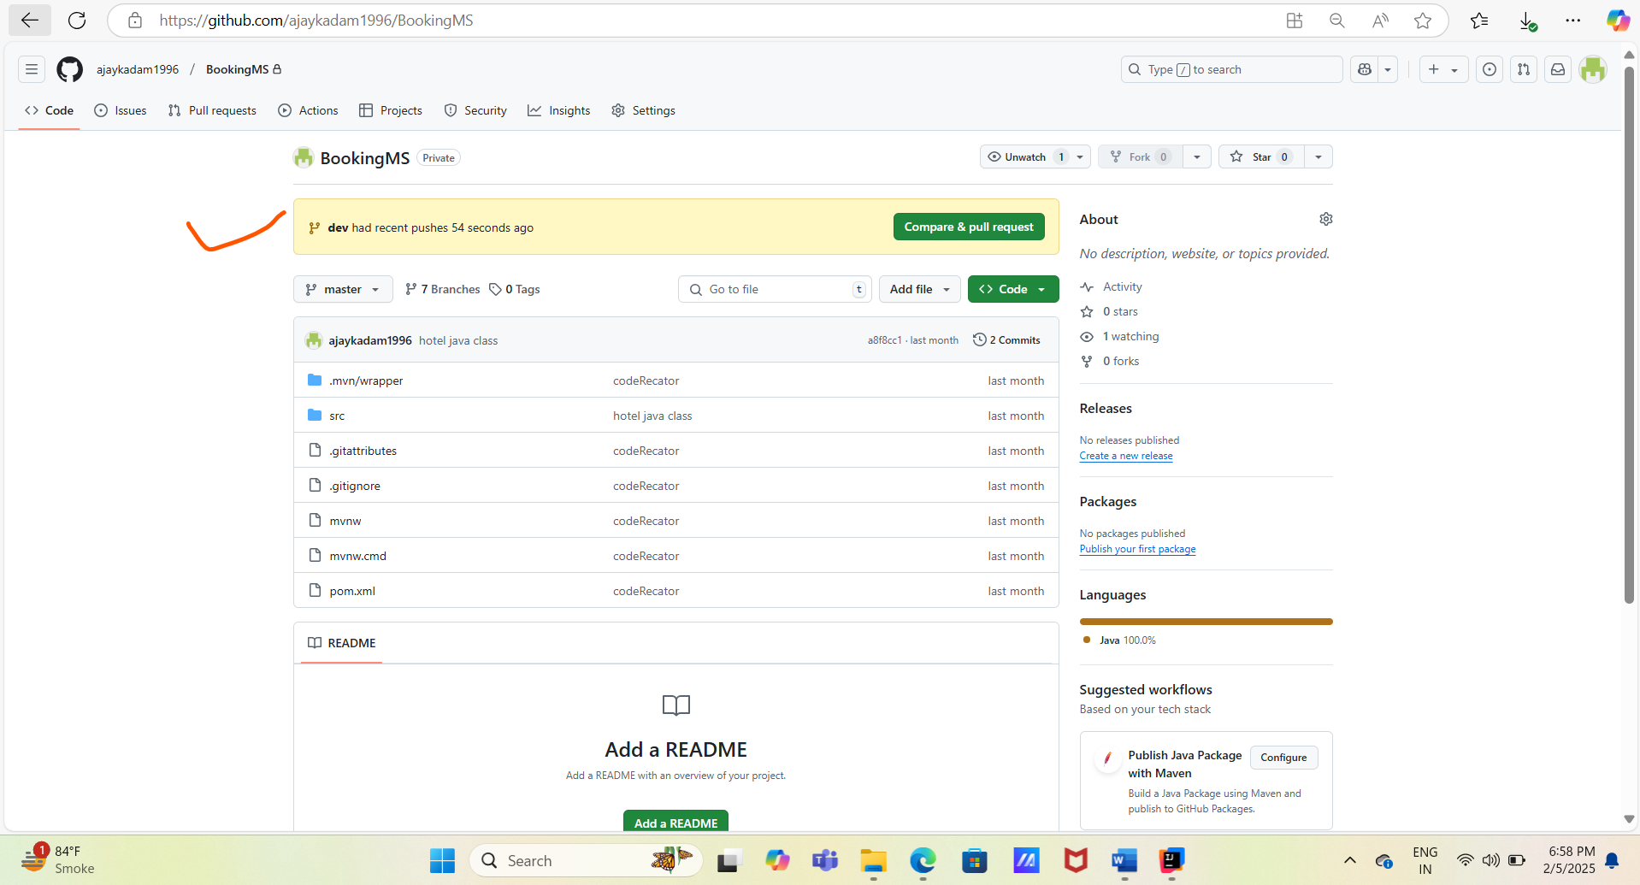

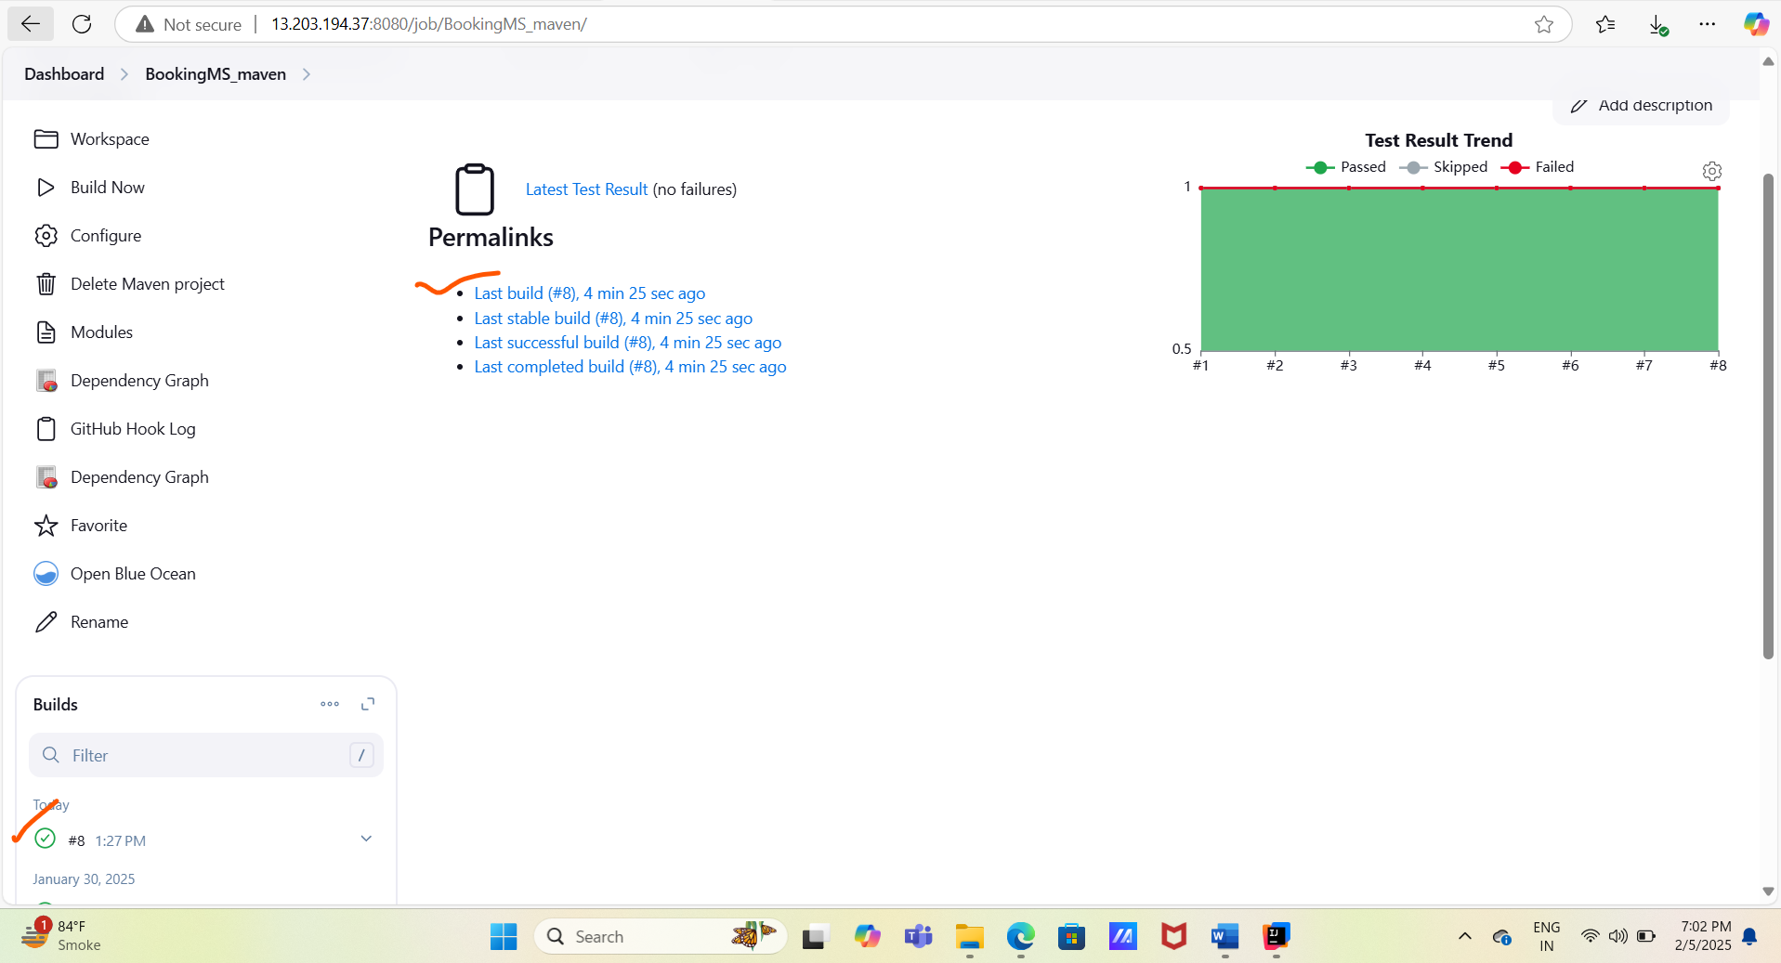

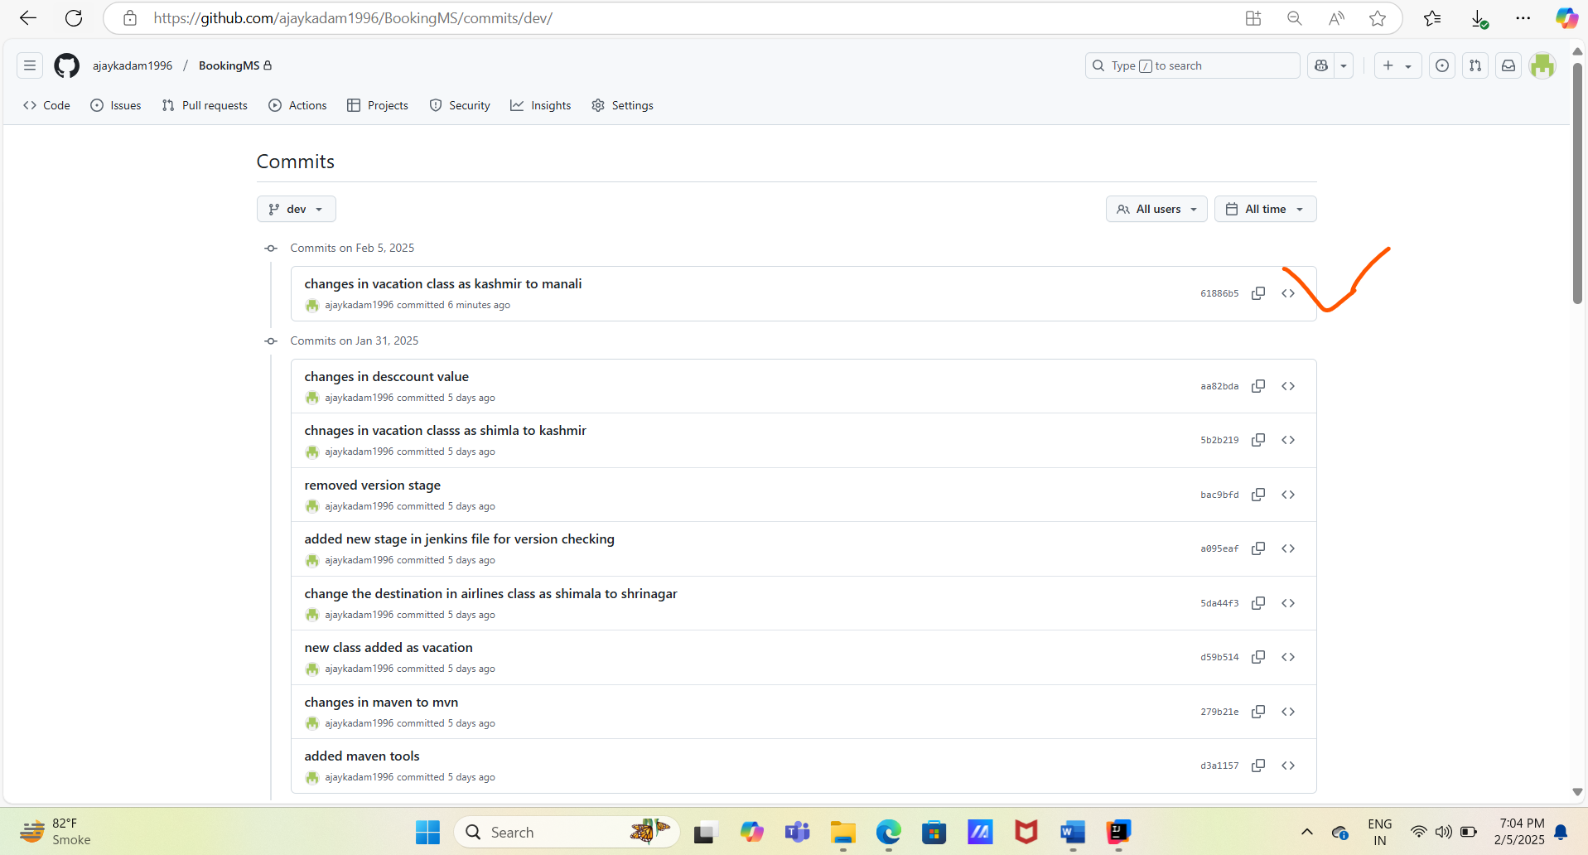

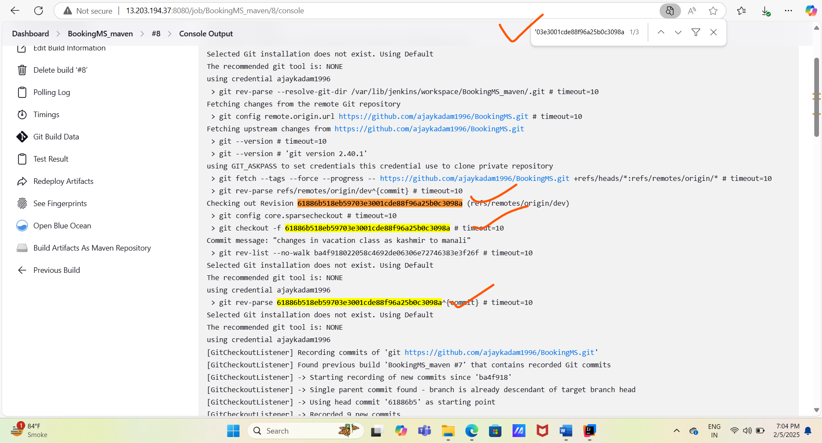

4.Declarative Pipeline Job Creation Steps. With build trigger # GitHub hook trigger for GITScm polling.

#Create a pipeline job as **BookingMS_Pipeline**

# Select build trigger as GitHub Hook

#In the pipeline filed select pipeline scrip as SCM. and Git as a SCV and add the GitHub repo URL with credentials, As we using private repo and select the git branch ex:- /dev

#Add newly added or created Jenkins file in the script path and save the pipeline.

# Now we have created or add new code and need to push this code from locate to remote (using IntelliJ and Git and GitHub).

# Once the new commit happen in the /dev branch pipeline job will run and compile, build and package newly added code using newly added Jenkins file.

# Need to add new code and test code using below commands.

--git status

--git branch

---git checkout dev

--git pull origin dev

--mvn clean compile

--mvn clean package

--git add –all

--git commit -m “new added java code or class”

--git push origin dev

#Once push completed then check status on GitHub

#Check pipeline job status

#Once the job is completed the check job console logs with commit id.



